A PROJECT REPORT

on

A Comparative Analysis of Machine Learning Models for
Air Quality and Pollution Assessment

Submitted to

KIIT Deemed to be University

In Partial Fulfillment of the Requirement for the Award of

BACHELOR’S DEGREE IN

COMPUTER SCIENCE ENGINEERING

BY

Anurag Mukherjee 2205361
Abhisek Mishra 2205523
Ankan Banerjee 2205534
Aritra Bera 2205541

UNDER THE GUIDANCE OF

Dr Amiya Ranjan Panda



SCHOOL OF COMPUTER ENGINEERING

KALINGA INSTITUTE OF INDUSTRIAL TECHNOLOGY

BHUBANESWAR, ODISHA - 751024

April 2025

KIIT Deemed to be University

School of Computer Engineering
Bhubaneswar, Odisha - 751024

CERTIFICATE

This is certify that the project entitled

A Comparative Analysis of Machine Learning Models for
Air Quality and Pollution Assessment

submitted by

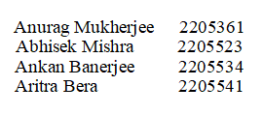

is a record of bonafide work carried out by them, in the partial fulfillment of the requirement for the award of Degree of Bachelor of Engineering (Computer Science & Engineering) at KIIT Deemed to be University, Bhubaneswar. This work is done during year 2024-2025, under our guidance.

Date: / / 2025

Dr Amiya Ranjan Panda

Project Guide
Acknowledgement

We are profoundly grateful to Dr Amiya Ranjan Panda of the School of Computer Engineering, KIIT Deemed to be University for his expert guidance and continuous encouragement throughout to see that this project rights its target since its commencement to its completion.

Anurag Mukherjee
Abhisek Mishra
Ankan Banerjee
Aritra Bera

Abstract

Air pollution remains a critical environmental and public health challenge, necessitating accurate classification of air quality levels. This study presents a comparative analysis of multiple machine learning models distinguishing air quality into several categories: Good, Moderate, Poor, and Hazardous. The dataset downloaded from Kaggle comprises 5000 samples with key environmental and demographic attributes such as temperature, humidity, pollutant concentrations and population density. A variety of machine learning classifiers, including Logistic Regression, Decision Tree, Random Forest, SVM, Gradient Boosting (GBM, XGBoost, CatBoost), and ensemble methods, were evaluated based on accuracy, precision, recall, and F1-score. The results indicate that ensemble methods like Random Forest, Extra Trees Classifier, and XGBoost achieved the highest accuracy (96.10% - 96.20%) and overall classification performance. Conversely, Bernoulli Naive Bayes exhibited the lowest accuracy (40.90%), highlighting its limitations in handling this dataset. Our study highlights the efficiency of machine learning in air quality assessment and its potential application in environmental monitoring and policy-making.

Keywords: Air Pollution, Data Science, Ensemble Learning, Multiclass Classification, XGBoost

Contents

1 | Introduction |  | 1
2 | Literature Review |  | 2-3
3 | Problem Statement |  | 4-7
 | 3.1. | Introduction to the Project | 4
 | 3.2. | Overall Description | 5
 | 3.3. | Project Planning | 5-6
 | 3.4. | Project Analysis | 6
 | 3.5. | System Design | 6-7
4 | Implementation |  | 8-13
 | 4.1. | Methodology | 8-11
 | 4.2. | Machine Learning Classifiers Used
 | 4.3. | Testing | 11-12
 | 4.4. | Result Analysis | 12-13
 | 4.5. | Challenges and Limitations
5 | Conclusion and Future Scope |  | 14-15
 | 5.1. | Conclusion | 14
 | 5.2. | Future Scope | 14-15
References |  |  | 16-17
Individual Contribution and Findings |  |  | 18-21
Plagiarism Report |  |  | 22

CHAPTER 1: INTRODUCTION

Air pollution is a significant environmental and public health challenge, contributing to respiratory diseases, cardiovascular complications, and reduced life expectancy. With rapid urbanisation and industrialisation, monitoring air quality has become essential for implementing effective pollution control strategies and issuing timely health advisories. Traditional air quality monitoring relies on physical sensors and manual observations, which, while reliable, are often expensive, resource-intensive, and geographically limited. Machine learning provides a scalable and efficient alternative by leveraging historical data to predict pollution levels accurately.

This study focuses on classifying air quality using machine learning techniques based on a dataset containing 5000 samples. The dataset captures key environmental and demographic factors that influence pollution levels. These include temperature, which affects the chemical behaviour of pollutants in the atmosphere, and humidity, which impacts pollutant dispersion and concentration. The dataset also includes critical air pollutants which are coarse particulate matter responsible for respiratory illnesses, as well as gaseous pollutants like nitrogen dioxide (NO₂), sulfur dioxide (SO₂), and carbon monoxide (CO), which originate primarily from combustion processes and industrial emissions. Additionally, proximity to industrial areas is considered a crucial factor, as regions closer to major industrial zones tend to experience higher pollution levels. Population density is also included, as human activities such as transportation and energy consumption contribute to air quality variations.

The classification problem involves four air quality levels: Good, Moderate, Poor, and Hazardous, determined based on pollutant concentrations and environmental conditions. To address this, we have used traditional classifiers like Logistic Regression, Decision Tree, Support Vector Machine (SVM), Random Forest, Gradient Boosting, XGBoost, and CatBoost, and probabilistic methods like Naïve Bayes, among others. Models are evaluated using accuracy, precision, recall, and F1-score to determine their effectiveness in predicting air quality levels.

CHAPTER 2: LITERATURE REVIEW

Air pollution remains a vital challenge with severe consequences for people’s health and the environment. Air quality monitoring systems rely on sensor-based networks and manual reporting, which, although effective, are costly and limited in coverage. In recent years, machine learning has been widely applied in air pollution prediction and classification, offering more efficient and scalable solutions. Various studies have explored different algorithms and data-driven methodologies to improve air quality assessment and forecasting.

One study examines the application of machine learning in predicting air pollution levels based on meteorological parameters and pollutant concentrations. The researchers employ decision tree-based ensemble methods such as Random Forest and Gradient Boosting to enhance predictive accuracy. Their findings highlight the effectiveness of machine learning models in capturing complex relationships between atmospheric conditions and pollution levels.

Another study integrates deep learning techniques, for real time monitoring using IoT-based sensor networks. The research demonstrates how deep learning can effectively process temporal and spatial air quality data, improving prediction accuracy compared to traditional statistical models.

In a separate study, the authors propose a hybrid approach integrating important feature choosing and classifiers to improve air quality classification. The study explores the impact of different parameters, such as temperature, humidity and pollutant concentrations, on classification performance. Support Vector Machines (SVM) and Naïve Bayes classifiers are used to differentiate air quality levels, with SVM achieving higher accuracy due to its capability to handle complex data.

Additionally, an IoT-driven framework for air quality prediction is developed, where data from multiple sensors is processed using machine learning models such as Decision Trees and K-Nearest Neighbors (KNN). The authors emphasise the significance of selecting appropriate features in improving the performance of the model and reducing computation time.

Another research study discusses the use of ensemble learning techniques, including XGBoost and CatBoost, in air pollution forecasting. The study shows that boosting-based models significantly outperform traditional classifiers due to their power to deal with unbalanced data and capture nonlinear relationships between environmental conditions.
To conclude, the usage of ML in air quality classification and prediction has gained significant traction. Studies have explored various approaches, including decision trees, ensemble learning and SVM, demonstrating their effectiveness in improving classification accuracy and prediction reliability. These advancements contribute to the development of robust, scalable air quality monitoring systems, ultimately aiding in pollution control efforts and public health protection.

CHAPTER 3: PROBLEM STATEMENT

Air pollution is a significant environmental and public health concern, leading to severe respiratory diseases, cardiovascular complications, and reduced life expectancy. Traditional air quality monitoring methods rely on physical sensors and manual observations, which, despite being reliable, are costly, resource-intensive, and geographically limited.

This project aims to develop a machine learning-based air quality classification system that can accurately categorize air quality levels into four categories: Good, Moderate, Poor, and Hazardous. By leveraging historical environmental data, including temperature, humidity, and pollutant concentrations (PM2.5, PM10, NO₂, SO₂, CO), the proposed system seeks to provide an efficient, scalable, and cost-effective solution for real-time pollution assessment.

3.1. INTRODUCTION TO THE PROJECT

- Purpose: The purpose of this project is to compare different machine learning models for air quality classification to determine the most efficient algorithm for pollution assessment.

- Scope: This project utilizes various supervised learning techniques, including Decision Trees, Random Forest, XGBoost, and Gradient Boosting, to classify air quality based on multiple environmental parameters.

- Definitions, Acronyms, and Abbreviations:

- PM2.5 & PM10: Fine particulate matter in the air affecting health.

- SVM: Support Vector Machine, a classification algorithm.

- XGBoost: Extreme Gradient Boosting, an optimised machine learning model.

- IoT: Internet of Things, a sensor-based network.

3.2. OVERALL DESCRIPTION

I. Product Perspective: The proposed product/system serves as an alternative to traditional air quality monitoring methods, providing automated classification using machine learning models.

II. Product Functions:

- Ingesting air quality data from environmental sources.
- Processing and analysing the dataset.
- Providing predictions on air quality levels.
- Training and evaluating multiple machine learning classifiers.

III. User Characteristics:

- Environment analysts.
- Governmental agencies for pollution control.
- Research organisations studying air quality trends.

3.3. PROJECT PLANNING

The project is to be executed in a structured manner, following these key steps:

- Requirements Gathering:

- Identifying the problem statement.
- Collecting the dataset containing air quality attributes.

- Data Preprocessing and Cleaning:

- Handling missing values.
- Converting categorical data into numerical form, if required.
- Normalising or scaling data to improve model performance.

- Exploratory Data Analysis (EDA):

- Analysing correlations between features.
- Generating visualisation charts (e.g., heatmaps, bar graphs).

- Model Selection & Training:

- Implementing various machine learning classifiers.
- Optimising hyperparameters for better performance.

- Model Evaluation & Comparison:

- Comparing models based on accuracy, precision, recall, and F1-score.
- Selecting the best-performing model.

- Results Interpretation & Conclusion:

- Interpreting the findings and discussing the feasibility of applying the model for real-world air quality monitoring.

3.4. PROJECT ANALYSIS

After defining the problem statement and collecting relevant data, an in-depth analysis is to be performed to identify ambiguities or inconsistencies in the dataset and model selection. Key aspects to be analysed include:

- Data Quality Assessment: Checking for missing, duplicate, or inconsistent data.

- Feature Importance Analysis: Evaluating the correlation of different features with air quality classification.

- Bias and Variance Analysis: Ensuring that the model does not overfit or underfit the data.

- Comparison of Models: Selecting the most accurate and reliable algorithm for air quality prediction.

3.5. SYSTEM DESIGN

The project is implemented in a software environment using:

- Hardware Requirements:

- Processor: Intel Core i5 or above
- RAM: Minimum 8GB
- Storage: Minimum 50GB available space

- Software Requirements:

- Programming Language: Python
- Libraries: Pandas, NumPy, Scikit-learn, XGBoost, Matplotlib
- IDE: Jupyter Notebook, VS Code
- Dataset: Kaggle dataset containing 5000 air quality samples

The system follows a structured pipeline:

- Data Collection:
The dataset is obtained from Kaggle.

- Data Preprocessing:
Missing values are handled, categorical data is converted, and features are normalised.

- Feature Selection:
The most relevant features influencing air quality are identified using correlation analysis.

- Model Training & Evaluation:
Various ML models are trained, and their performance is evaluated using classification metrics.

- Air Quality Prediction:
The best-performing model is used to classify air quality levels.

CHAPTER 4 : IMPLEMENTATION

4.1. METHODOLOGY

The project follows a structured methodology that includes data preprocessing, feature selection, model training, and performance evaluation. The steps adopted are as follows:

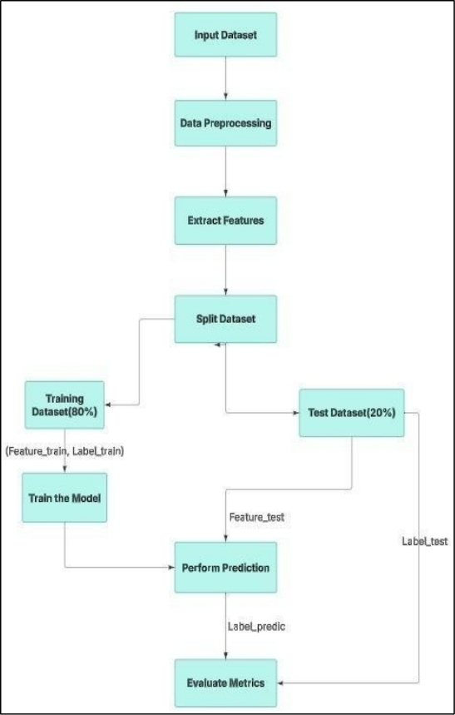

Fig. 4.1: Flowchart for the whole process of model implementation

Step 1: Data Collection and Preprocessing

- The dataset was sourced from Kaggle, containing 5000 air quality samples with attributes like temperature, humidity, pollutant concentrations (PM2.5, PM10, NO₂, SO₂, CO), and population density.

- Missing values were handled by mean imputation for numerical data and mode imputation for categorical data.

- The dataset was normalised using MinMax Scaling to improve the efficiency of machine learning models.

- The relative significance of various attributes in the dataset was visualised with the help of a feature importance graph. The graph highlights that Carbon Monoxide (CO) and Industrial_Areas are the most influential features, with importance scores of approximately 0.30 and 0.35, respectively. Other notable features include Nitrogen Dioxide (NO2) and Sulfur Dioxide (SO2), which also contribute significantly to the model's predictive power. Attributes such as PM2.5, PM10, Humidity, Temperature, and Population_Density show lower levels of importance, indicating their roles in assessing air quality. This analysis provides crucial insights into which factors most affect air pollution levels, guiding future modeling efforts.

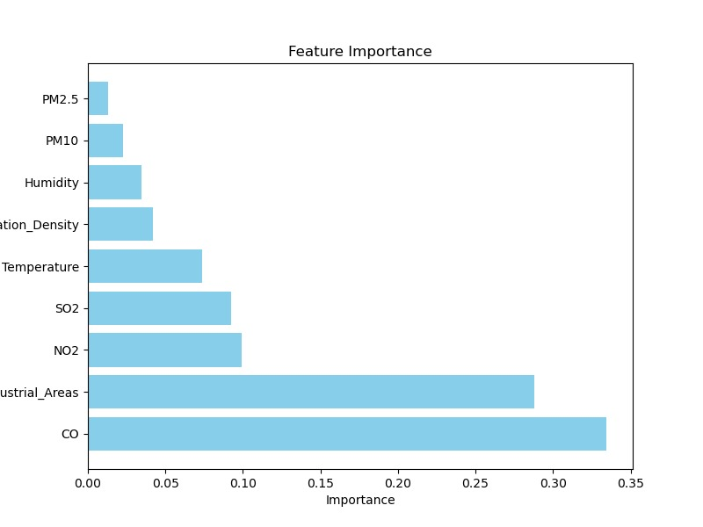

Fig. 4.3: Bar graph showing the feature importance of dataset attributes

- The t-SNE visualisation of the dataset effectively clusters data points based on air quality classifications, indicated by distinct colors ranging from yellow to purple. Each cluster demonstrates varying densities, suggesting that certain air quality categories are more prevalent in specific regions of the feature space. This graphical representation provides a foundation for refining machine learning models and enhancing their predictive accuracy in assessing air pollution.
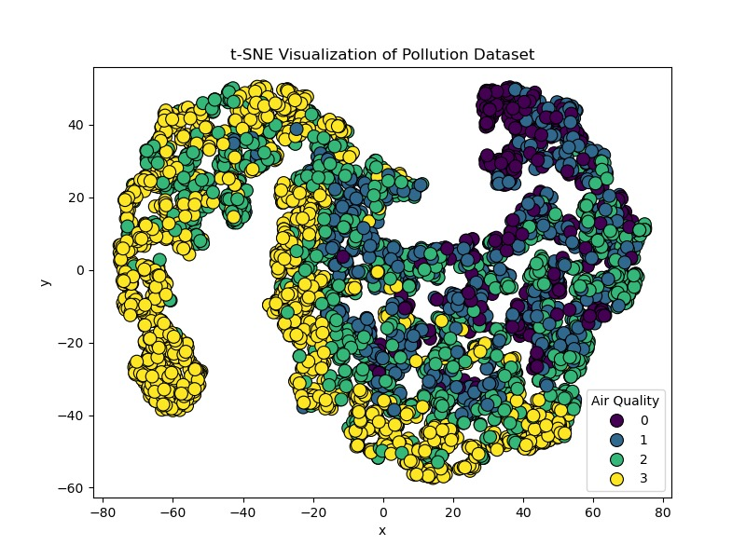
Fig. 4.4: t-SNE graphical representation of the dataset

Step 2: Feature Engineering

- Correlation analysis was conducted using a heatmap to identify the most important features, i.e., those having the strongest correlation with Air Quality.

- The most significant feature identified is CO (Carbon Monoxide), which has a correlation of -0.91, indicating that higher CO levels strongly degrade air quality. The second highest correlation is observed with NO2 (Nitrogen Dioxide) at -0.79, showing that higher NO2 concentrations also result in poor air quality.

- Additionally, Industrial_Areas demonstrates a correlation of 0.77, implying that proximity to industrial zones plays a major role in air pollution.

.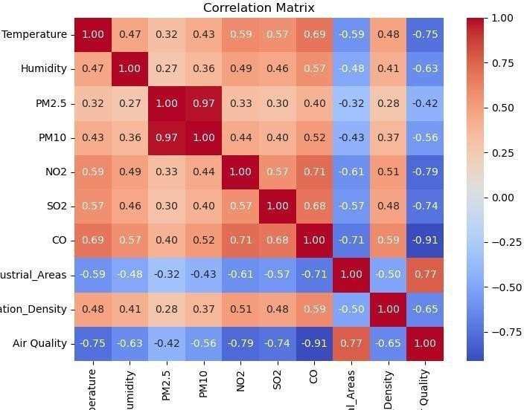

Fig. 4.2: Correlation matrix visualisation of all the features in the dataset

- Likewise, PM2.5 (Particulate Matter) exhibits a correlation of -0.74, reinforcing its impact on air quality deterioration. The negative correlations signify that as pollutant levels rise, air quality declines markedly.

- Accordingly, less relevant features were removed to reduce model complexity.

Step 3: Model Selection and Training

The following machine learning models were trained on the dataset:

- Logistic Regression
- K-Nearest Neighbors (KNN)
- Decision Tree
- Random Forest
- Naïve Bayes Classifier
- Support Vector Machine (SVM)
- Gradient Boosting (AdaBoost, GBM, CatBoost, XGBoost)
- Extra Trees Classifier
- Bagging Classifier
- Stochastic Gradient Descent (SGD) Classifier
- Ridge Classifier
- Bernoulli Naïve Bayes Classifier
- Passive Aggressive Classifier

Step 4: Performance Evaluation

- The models were tested on a 20% test dataset, ensuring unbiased evaluation.

- They were then evaluated using accuracy, precision, recall, and F1-score.

- The best-performing models were XGBoost (96.10%), Random Forest (96.10%), and Extra Trees Classifier (96.20%), confirming that these models were the most effective for air quality classification.

4.2. MACHINE LEARNING CLASSIFIERS USED
In this study, various machine learning classifiers were implemented to analyze and predict air quality. Below is a brief explanation of each classifier:

1. Logistic Regression
Logistic Regression is a statistical model that uses a logistic function to model binary dependent variables. It is widely used for classification problems, where the output is categorical. The model predicts the probability that a given input belongs to a particular class using the sigmoid function.

2. K-Nearest Neighbors (KNN)
KNN is a non-parametric, instance-based learning algorithm that classifies data points based on the majority class of their nearest neighbors. The number of neighbors (K) is a crucial hyperparameter that affects model performance.

3. Decision Tree
A Decision Tree is a hierarchical model that splits the data into subsets based on feature values. Each internal node represents a decision based on a feature, and each leaf node represents a class label. Decision Trees are interpretable but prone to overfitting.

4. Random Forest
Random Forest is an ensemble learning method that constructs multiple Decision Trees and combines their outputs for improved accuracy and generalization. It reduces overfitting and increases robustness by aggregating the predictions of various trees.

5. Naïve Bayes Classifier
The Naïve Bayes Classifier is based on Bayes' Theorem and assumes independence between features. It is particularly effective for text classification and spam detection due to its simplicity and efficiency.

6. Support Vector Machine (SVM)
SVM is a supervised learning algorithm that finds the optimal hyperplane that maximally separates different classes in the feature space. It is useful for high-dimensional data and works well with both linear and non-linear decision boundaries.

7. Gradient Boosting (AdaBoost, GBM, CatBoost, XGBoost)
Gradient Boosting is an ensemble learning technique that builds models sequentially, with each new model correcting errors from the previous one. Variants like AdaBoost, GBM, CatBoost, and XGBoost improve performance using different boosting techniques.
- AdaBoost (Adaptive Boosting): Assigns higher weights to misclassified instances in each iteration.
- GBM (Gradient Boosting Machine): Optimizes models using a gradient descent approach.
- CatBoost: Optimized for categorical data, reducing the need for extensive preprocessing.
- XGBoost: Efficient and scalable, often used in data science competitions.

8. Extra Trees Classifier
Extra Trees (Extremely Randomized Trees) is similar to Random Forest but differs in how it selects split points. It uses more randomness, leading to reduced variance but potentially lower accuracy.

9. Bagging Classifier
Bagging (Bootstrap Aggregating) is an ensemble method that reduces variance by training multiple models on random subsets of data and averaging their predictions. It enhances stability and performance.

10. Stochastic Gradient Descent (SGD) Classifier
SGD is an optimization algorithm used for training models in an incremental manner. It is particularly useful for large-scale datasets and online learning tasks.

11. Ridge Classifier
Ridge Classifier is a variation of linear regression that applies L2 regularization to prevent overfitting. It is effective when dealing with collinear features.

12. Bernoulli Naïve Bayes Classifier
A variation of Naïve Bayes suited for binary/boolean features, commonly used for text classification tasks like spam filtering.

13. Passive Aggressive Classifier
A fast and efficient online learning algorithm that updates the model only when it misclassifies an instance, making it suitable for real-time applications.

4.3. TESTING

To validate the performance of the developed models, multiple test cases were created to check accuracy. The table below presents a structured test case format:
Test ID | Test Case Title | Test Condition | System Behaviour | Expected Result
T01 | Data Preprocessing Verification | Checking if missing values are handled correctly. | The system should fill missing values appropriately. | The dataset should not have any missing values.
T02 | Feature Selection Accuracy | Identifying the most correlated features. | The system should correctly identify key features. | Important features like CO and NO₂ should be prioritised.
T03 | Model Performance on Test Set | Evaluating the model on 20% unseen test data. | The model should provide consistent accuracy. | The accuracy should be above 90% for the best models.
T04 | Classification Consistency | Inputting same values multiple times. | The model should give the same classification output. | Output should be stable for same inputs.
T05 | Outlier Handling | Providing extreme values in the dataset. | The model should not misclassify due to the extreme values. | Robustness should be maintained.

These test cases ensure that the system functions correctly under different conditions, verifying model stability and accuracy.

4.4. RESULT ANALYSIS

The comparative analysis of the different machine learning models shows that certain ensemble techniques outperform traditional classifiers in air quality assessment. Below is the tabular representations of key results:
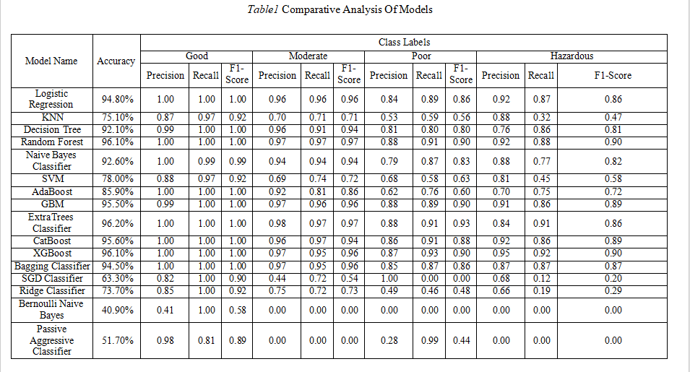
Fig. 4.5: Comparative analysis of the models

The table in Figure 4.5 presents the evaluation outcomes of different models on the air pollution data. The results indicate that ensemble methods like Random Forest, XGBoost, and Extra Trees Classifier achieved the highest accuracy (96.10% - 96.20%) and overall classification performance. Conversely, the Bernoulli Naive Bayes Classifier exhibited the lowest accuracy (40.90%), highlighting its limitations in handling this dataset.

However, it is important to note that accuracy alone might not be a sufficient metric to capture the performance of a model, especially when datasets are unbalanced or when the costs associated with classification differ from class to class.
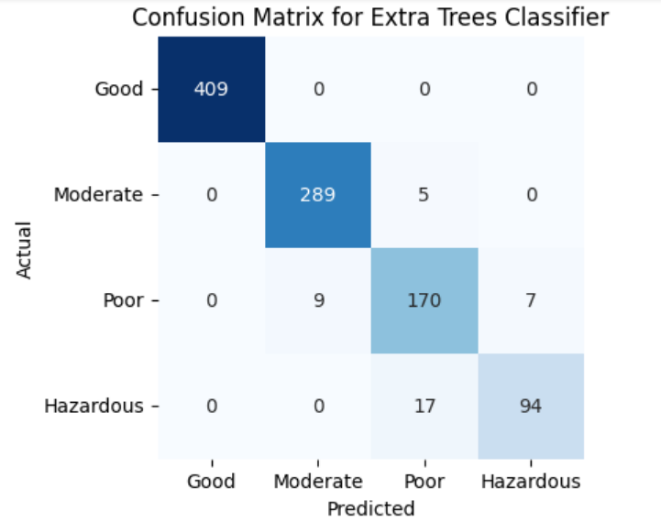

Fig. 4.6: Confusion matrix of the Extra Trees Classifier model, with an accuracy of 96.20%
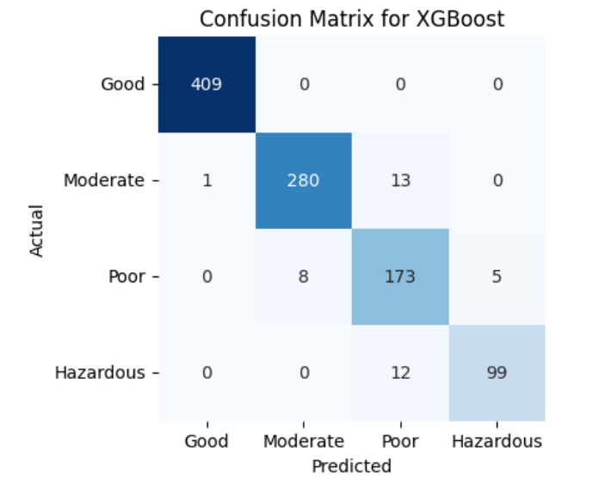

Fig. 4.7: Confusion matrix of the XGBoost model, with an accuracy of 96.10%

4.5. CHALLENGES AND LIMITATIONS

During the development of this project, several challenges were encountered, ranging from data-related issues to implementation complexities. The major challenges faced are outlined below:

1. Data Collection and Preprocessing

- The dataset obtained from Kaggle required extensive verification and preprocessing. Missing values, inconsistencies, and redundant features had to be handled carefully to ensure the accuracy of model predictions.
- Balancing the dataset was another challenge since certain pollution levels were underrepresented, leading to potential bias in the classification results.

2. Model Selection and Hyperparameter Tuning

- Choosing the most effective classifier among multiple machine learning models was a significant challenge. While some models performed well in terms of accuracy, others were more interpretable but less accurate.
- Optimizing hyperparameters for models like Random Forest, Gradient Boosting, and SVM required extensive tuning, increasing computational time.

3. Computational Complexity and Processing Power

- Training multiple classifiers and evaluating their performance demanded considerable computational resources. Running complex models like XGBoost and Gradient Boosting on large datasets took a significant amount of time.
- Limited hardware capabilities occasionally led to system slowdowns, requiring efficient resource management.

4. Performance Evaluation and Metric Interpretation

- Understanding the trade-offs between precision, recall, F1-score, and accuracy was essential to assess the classifiers effectively. Some models performed well in accuracy but had poor recall, making them unreliable for certain predictions.
- Visualizing the results through confusion matrices and ensuring fair comparisons across models required careful analysis.
5. Literature Review and Theoretical Understanding

- Reviewing existing research papers to build a strong foundation for the literature survey was time-consuming. Understanding complex ML algorithms and their applications in air quality prediction required in-depth study.

6. Code Debugging and Implementation Issues

- Writing optimized Python code for multiple classifiers, debugging errors, and ensuring compatibility with different libraries (such as scikit-learn, pandas, and matplotlib) required thorough testing.
- Handling data format mismatches and ensuring smooth integration of different preprocessing techniques was challenging.

7. Time Constraints and Project Coordination

- Managing time efficiently while balancing coursework and project deadlines was a challenge.
- Coordinating with team members for literature review, coding, and documentation required effective communication to avoid redundancies and inconsistencies.

CHAPTER 5: CONCLUSION AND FUTURE SCOPE

5.1. CONCLUSION

This study presented a comparative analysis of various machine learning models for air quality and pollution assessment. The objective was to classify air quality into four categories—Good, Moderate, Poor, and Hazardous—using environmental parameters such as temperature, humidity, PM2.5, PM10, NO₂, SO₂, CO concentrations, and population density.

Through extensive evaluation, it was found that ensemble methods such as Extra Trees Classifier, Random Forest, and XGBoost consistently outperformed traditional classifiers like Logistic Regression, SVM, and KNN, achieving accuracy levels of 96.10% - 96.20%. These models demonstrated high precision, recall, and F1-score, making them suitable for real-world pollution classification applications.

The findings of this project highlight the effectiveness of machine learning-based air quality assessment over conventional monitoring techniques, which are often expensive and geographically limited. The results emphasize that data-driven approaches can significantly contribute to environmental monitoring, policy-making, and public health awareness by providing accurate pollution predictions.

Thus, this research successfully demonstrates how machine learning can be leveraged for scalable and cost-effective air quality classification, paving the way for automated and real-time air pollution monitoring solutions.

5.2. FUTURE SCOPE

While this project provides a robust foundation for machine learning-based air quality classification, there are several areas where improvements and expansions can be made:

1. Real-time Data Integration:

Currently, the model is trained on a static dataset. Future work could integrate real-time air quality data from IoT-based sensor networks to enable live air pollution predictions.

2. Advanced Deep Learning Models:

The study focused on traditional machine learning techniques. Future research could explore deep learning models, such as Recurrent Neural Networks (RNNs) and Transformers, which can capture temporal trends in air pollution data more effectively.

3. Geographic and Meteorological Expansion:

The dataset used in this project is limited to specific environmental conditions. Expanding the study by incorporating meteorological data (wind speed, atmospheric pressure) and geographical data (altitude, urbanisation levels) can enhance prediction accuracy.

4. Hybrid Machine Learning Models:

Combining multiple algorithms into a hybrid ensemble model can further improve prediction accuracy and robustness. Techniques like Stacking or Weighted Voting could be explored to create even more efficient classifiers.

5. Deployment as a Web or Mobile Application:

The model can be deployed as an API, web, or mobile application that provides real-time air quality predictions for users, helping governments, industries, and individuals make informed decisions regarding air pollution control.

6. Collaboration with Government and Environmental Agencies:

Future work could involve collaborations with policymakers, pollution control boards, and environmental agencies to integrate machine learning-based pollution forecasting into decision-making frameworks.

7. Explainable AI for Transparency:

Implementing Explainable AI (XAI) techniques can help interpret how models make predictions, improving trust in machine learning-based air quality monitoring systems.

This study on machine learning models for air quality and pollution assessment lays the foundation for future research and advancements in predictive analytics for environmental monitoring.
Further advancements in this field can explore the following areas to enhance the effectiveness and applicability of machine learning in air quality assessment:

- Integration with Deep Learning Models:
While traditional machine learning classifiers have demonstrated effectiveness, deep learning techniques such as Convolutional Neural Networks (CNNs) and Long Short-Term Memory (LSTM) networks can be explored for better time-series forecasting of air pollution trends. These models can help capture spatial and temporal dependencies in the data more effectively.

- Feature Engineering and Data Augmentation:
The performance of ML models can be further improved by incorporating advanced feature selection techniques and synthetic data generation to handle missing values or enhance training data. Techniques like Principal Component Analysis (PCA) and autoencoders could be explored for feature extraction.

- Real-Time Air Quality Monitoring with IoT:
Future studies can integrate Internet of Things (IoT) sensors for real-time data collection and processing. By connecting ML models with edge computing and cloud-based solutions, air quality monitoring systems can be automated, providing timely alerts to the public and policymakers.

- Explainable AI (XAI) for Interpretability:
One major challenge with complex models like ensemble methods and boosting techniques is interpretability. Future research can focus on incorporating Explainable AI (XAI) techniques such as SHAP (Shapley Additive Explanations) and LIME (Local Interpretable Model-agnostic Explanations) to make model predictions more transparent.

- Integration with Geographic Information Systems (GIS):
GIS-based mapping of pollution levels can be combined with ML models to develop interactive dashboards. This can help in visualizing pollution hotspots and making data-driven decisions for urban planning and environmental regulation.

- Hybrid Models and Ensemble Techniques:
Instead of using individual classifiers, future work can explore hybrid models combining multiple algorithms. For example, stacking or voting-based ensemble models can be used to improve prediction accuracy by leveraging the strengths of multiple classifiers.

- Policy Implications and Decision Support Systems:
The insights from ML models can be used by policymakers for better environmental regulation. Future work can focus on integrating ML-driven predictions with government air quality standards to aid in the formulation of pollution control policies.

- Deployment as a Web or Mobile Application:
The ML models developed in this project can be deployed as a real-time web or mobile application that provides users with localized air quality predictions. This can help citizens make informed decisions regarding outdoor activities based on pollution levels.
·
By incorporating these advancements, the research can significantly contribute to improving air pollution prediction, real-time monitoring, and proactive environmental management.

REFERENCES

- Pattnayak P, Panda AR. Innovation on machine learning in healthcare services—An introduction. Technical Advancements of Machine Learning in Healthcare. 2021:1-30.
- Mishra S, Tripathy HK, Panda AR. An improved and adaptive attribute selection technique to optimize dengue fever prediction. Int J Eng Technol. 2018;7:480-6.

- Larkin A, Hystad P. Towards personal exposures: how technology is changing air pollution and health research. Current environmental health reports. 2017 Dec;4:463-71.
- Devi M, Dhaya R, Kanthavel R, Algarni F, Dixikha P. Data Science for Internet of Things (IoT). In Second international conference on computer networks and communication technologies: ICCNCT 2019 2020 (pp. 60-70). Springer International Publishing.

- Zhao X, Zhang R, Wu JL, Chang PC. A Deep Recurrent Neural Network for Air Quality Classification. J. Inf. Hiding Multim. Signal Process.. 2018 Mar;9(2):346-54.
- Guo, G., Wang, H., Bell, D., Bi, Y. and Greer, K., 2003. KNN model-based approach in classification. In On The Move to Meaningful Internet Systems 2003: CoopIS, DOA, and ODBASE: OTM Confederated International Conferences, CoopIS, DOA, and ODBASE 2003, Catania, Sicily, Italy, November 3-7, 2003. Proceedings (pp. 986-996). Springer Berlin Heidelberg.

- Hancock JT, Khoshgoftaar TM. CatBoost for big data: an interdisciplinary review. Journal of big data. 2020 Nov 4;7(1):94.
- Chen T, Guestrin C. Xgboost: A scalable tree boosting system.In Proceedings of the 22nd ACM SIGKDD international conference on knowledge discovery and data mining 2016 Aug 13 (pp. 785-794).
- Breiman L. Bagging predictors. Machine learning. 1996 Aug;24:123-40.

- Woodworth B, Patel KK, Stich S, Dai Z, Bullins B, Mcmahan B, Shamir O, Srebro N. Is local SGD better than minibatch SGD?. In International Conference on Machine Learning 2020 Nov 21 (pp. 10334-10343). PMLR.
- Hastie T. Ridge regularization: An essential concept in data science. Technometrics. 2020 Oct 1;62(4):426-33.

- Dai B, Ding S, Wahba G. Multivariate bernoulli distribution.
- Steiger JH. Tests for comparing elements of a correlation matrix. Psychological bulletin. 1980 Mar;87(2):245.

- Van der Maaten L, Hinton G. Visualizing data using t-SNE. Journal of machine learning research. 2008 Nov 1;9(11).
- Townsend JT. Theoretical analysis of an alphabetic confusion matrix. Perception & Psychophysics. 1971 Jan;9:40-50.

A Comparative Analysis of Machine Learning Models for Air Quality and Pollution Assessment

ANURAG MUKHERJEE
2205361

INDIVIDUAL CONTRIBUTION AND FINDINGS

In this project, I contributed to various aspects, including data analysis, model implementation, result assessment, and report finalization. My contributions can be summarised as follows:

1. Dataset Analysis: I conducted a comprehensive study of the obtained dataset, carefully examining its features, and framed detailed descriptions of each feature, highlighting their significance and potential impact on the model's performance.

- Model Implementation and Analysis: I developed and implemented four machine learning models: CatBoost, XGBoost, Extra Trees Classifier, and Bernoulli Naive Bayes Classifier. For each model, I generated confusion matrices to visualise performance metrics, including accuracy, precision, recall, and F1-score.

- Assessment of Results: I thoroughly assessed the results from all implemented models, and drafted the Conclusion section, summarising the findings and their implications. I outlined potential future work, suggesting areas for further research and improvement.

- Report Editing and Finalisation: In the final stages of the project, I took on the responsibility of editing and finalising the project report. This included reviewing the content of the entire report, ensuring that it adhered to the specified guidelines and maintained a consistent formatting throughout, and including suitable images to provide a clearer understanding of the results. At the end, I conducted a thorough proofread to eliminate any grammatical errors and enhance the overall quality of the document.

This contribution report reflects my active engagement and significant findings throughout the project life cycle.

A Comparative Analysis of Machine Learning Models for Air Quality and Pollution Assessment

ABHISEK MISHRA
2205523

INDIVIDUAL CONTRIBUTION AND FINDINGS

In this project, I played a vital role in several key areas, including dataset validation, conducting research, preparing reports, and implementing the model. My contributions can be outlined as follows:
- Dataset Preprocessing: I gathered and preprocessed a pollution dataset from Kaggle, and then conducted exploratory data analysis (EDA) to identify trends, address missing values, and examine correlations among features.

- Model Implementation and Analysis: I developed and trained four machine learning models, namely Decision Tree Classifier, Naïve Bayes Classifier, Bagging Classifier, and Ridge Classifier, to predict air quality. I evaluated the models based on accuracy, precision, recall, and F1-score, and created confusion matrices for performance analysis.

- Basic Concepts: I compiled theoretical explanations on fundamental research concepts, including Logistic Regression, K-Nearest Neighbors (KNN), and other relevant machine learning algorithms. Additionally, I designed a flowchart illustrating the process of fire detection using IoT devices as part of the research extension and provided relevant references for documentation.

- Methodology and Testing: Under implementation, the methodology covers data preprocessing, feature selection, model training, and evaluation, while testing ensures accuracy, consistency, and robustness.

The contribution report showcases my technical contributions and key findings throughout the project life cycle.

A Comparative Analysis of Machine Learning Models for Air Quality and Pollution Assessment

ANKAN BANERJEE
2205534

INDIVIDUAL CONTRIBUTION AND FINDINGS

In this project, I contributed to multiple key areas, including dataset verification, research, report preparation, and model implementation. My role can be summarized as follows:

- Dataset Verification: I verified the dataset obtained from Kaggle to ensure its correctness, completeness, and relevance for our study. This step was crucial in maintaining data integrity and improving model reliability.

- Model Implementation and Analysis: I implemented and analyzed the performance of four classifier models: AdaBoost, Gradient Boosting Machine (GBM), Random Forest, and Passive Aggressive Classifier. Additionally, I worked on visualizing results and computing the confusion matrix for these models to evaluate their accuracy and efficiency.

- Literature Survey Contribution: I contributed to the Literature Survey section in the research paper by analyzing previous works and compiling essential references that support our study. I also gathered and included appropriate references for documentation.

- Report Writing: I played an active role in writing the Literature Review and Problem Statement sections of the project report. My responsibility involved structuring these sections to present a clear and well-organized discussion.

The contribution report highlights my technical involvement and findings throughout the project life cycle.

A Comparative Analysis of Machine Learning Models for Air Quality and Pollution
Assessment

ARITRA BERA
2205541

INDIVIDUAL CONTRIBUTION AND FINDINGS

In this project, I contributed to multiple key areas, including dataset selection from Kaggle, research, report preparation, and model implementation. My role can be summarised as follows:

- Dataset Selection: I obtained the dataset obtained from Kaggle to ensure its correctness, completeness, and relevance for our study. The selection of an appropriate dataset was essential so that we could obtain comprehensive analysis of machine learning models.

- Model Implementation and Analysis: I implemented and analysed the performance of four classifier models: Logistic Regression, K-Nearest Neighbors (KNN), Support Vector Machine (SVM), and Stochastic Gradient Descent (SGD) Classifier. Additionally, I worked on visualising results and computing the confusion matrix for these models to evaluate their accuracy and efficiency.

- Literature Survey Contribution: I contributed to the Methodology, Abstract and Introduction sections in the research paper by analyzing previous works and compiling essential references that support our study. I also gathered and included appropriate references for documentation.

- Report Writing: I played an active role in writing the Abstract, Testing and Result Analysis sections of the project report. My responsibility involved structuring these sections to present a clear and well-organised discussion.

The contribution report highlights my technical involvement and findings throughout the project life cycle.

PLAGIARISM REPORT

